A Multi-Classifier System for Early Autism Spectrum Disorder Detection using Machine Learning

¹Brijit Adak ²Saurabh Sushant ³Arijit Mistry
School of Computer Engineering School of Computer Engineering School of Computer Engineering
KIIT Deemed to be University KIIT Deemed to be University KIIT Deemed to be University
Bhubaneswar, India Bhubaneswar, India Bhubaneswar, India
21052410@kiit.ac.in 21051335@kiit.ac.in 21051721@kiit.ac.in
⁴Diptendra Maity ⁵Abhaya Kumar Sahoo
School of Computer Engineering School of Computer Engineering
KIIT Deemed to be University KIIT Deemed to be University
Bhubaneswar, India Bhubaneswar, India
21051562@kiit.ac.in abhaya.sahoofcs@kiit.ac.in

Abstract—Developing a precise and efficient diagnostic system Due to its wide-ranging characteristics, autism spectrum disorder presents significant challenges. the condition, where symptoms and thresholds vary widely among individuals. Furthermore, the process of generating detailed behavioral assessments by healthcare specialists is both time-consuming and labor-intensive. Identifying and addressing ASD early is vital for enhancing the quality of life for those affected. Machine Learning (ML) algorithms offer a promising solution to identify and evaluate the presence of ASD more effectively. This study focuses on creating a prediction model utilizing multiple classifiers to make the accuracy , precision of Austism detection more exact.
Keywords—ANN, Autism Sprectrum Disorder (ASD), Classification Algorithm, Decision Tree, KNN, Logistic Regression, Machine Learning, Naive Bayes, Prediction Model, Randoom Forest, SVM.

Introduction
- Autism Spectrum Disorder
Autism Spectrum Disorder is a multi-faceted neuro-developmental disease characterized by constant challenges in social gatherings and talking, along with restricted or reccuring behaviors. First recognized by Leo Kanner and Hans Asperger in the early 20th century, Autism Spectrum Disorder has garnered considerable attention in not so far years because of its widespread prevalence and the profound effect it has on individuals and families worldwide.
Although the precise causes of Autism Disorder (ASD) are still to be found out, generally known happens from combination of genetic influence and also environmental influences to some extent. Studies indicate that particular genetic mutations and prenatal conditions might role in the development of ASD, although the actual mechanisms are yet to be fully understood.
The spectrum aspect of Autism Spectrum Disorder implies that individuals could display a wide range of symptoms and varying extent of challenges. While some people may show only mild symptoms and manage daily activities with little difficulty, others might require significant assistance for everyday living. This variability highlights the importance of early diagnosis and personalized interventions to meet each individual's unique needs.
Despite the difficulties that come with ASD, many individuals having the situation possess certain unique capabilities and talents. Using appropriate work and accommodations, they could lead to their fulfilling lives and help them on making valuable contributions to the society.
- Objective
With the exponential An increase in frequency of Autism in case involving children globally, the need for early detection has become more pressing. Early and accurate diagnosis of ASD requires expert intervention and is highly sought after to improve outcomes.
In this paper, we will delve into the various aspects of Autism Spectrum Disorder, including its diagnostic criteria, algorithms, limitations, comparisons among the algorithms to find the best one, prevalence, potential causes, and available interventions. Gaining a more thorough understanding of Autism Spectrum Disorder (ASD) helps improve awareness, foster acceptance, and provide better support for those affected by the condition.The motive of this research work is to efficiently catagorize patients in affected by ASD or notusing multi classifier based recommender system.
This paper is organized as follows:
Section 2 tells about literature study, section 3 describes methodology, section 4 tells about System Architecture, section 5 describes dataset used in the paper, section 6 narrates Comparision Studies, section 7 tells about Experimental Results and section 8 covers Limitations.

Literature Review

Machine Learning Algorithms in Autism
The leveraging of machine learning algorithms in ASD research has benefitted substantial gains over recent years. These algorithms have been instrumental in early diagnosis, behavioral analysis, and personalized intervention strategies.
Early and coorect diagnosis of ASD is useful for timely intervention. Traditional diagnostic methods are often subjective and time-consuming. Machine learning offers a promising alternative by analyzing patterns in genetic, neuroimaging, and behavioral data. Studies like Duda et al. (2016) utilized Support Vector Machines (SVM) and achieved significant accuracy in identifying ASD from brain imaging data. Similarly, Convolutional Neural Networks (CNNs) have promised for distinguishing between ASD and neurotypical development using facial recognition and eye-tracking data (Liu et al., 2016).
ML algorithms also contribute to understanding and predicting behaviors in individuals with ASD. For instance, Kanne et al. (2011) applied Random Forests to behavioral data to predict aggression and self-injurious behaviors. Natural Language Processing (NLP) techniques, different types of neural networks, including Long Short-Term Memory network, are utilized for analysis, communication patterns, aiding in the assessment of social interaction deficits typical of ASD (Fusaroli et al., 2017).
Personalized intervention is another area where ML is making significant strides. Reinforcement Learning algorithms, particularly Q-learning, can tailor educational and therapeutic programs to individual needs. For example, Koegel et al. (2020) developed an adaptive learning system using Q-learning that adjusts its teaching strategies based on real-time feedback from the child's performance, improving engagement and learning outcomes.
Despite these advancements, several challenges remain. One major issue is the heterogeneity of ASD, which complicates the development of universal ML models. Additionally, there are concerns about the ethical implications of using ML in sensitive areas like ASD, particularly regarding data privacy and the potential for bias.
Future studies should aim to enhance the robustness of these methods and on developing generalizable models and addressing ethical concerns. Integrating multimodal data and utilizing advanced techniques like Explainable AI (XAI) could enhance the interpretability and reliability of ML applications in ASD.
In summary, machine learning models and techniques, including Support Vector Machines and Neural Networks, offer significant capabilities, Random Forests, Long Short-Term Memory network, and Q-learning hold significant potential for transforming the landscape of ASD diagnosis, behavior analysis, and intervention. Continued interdisciplinary collaboration and ethical considerations will be key to realizing the full benefits of these technologies.
Here we are using ANN, Decision Tree, Randoom Forest, SVM, Logistic Regression(LR), Naive Bayes(NB) and KNN Machine Learning models to classify the patient among Autism affected or not.

Severity Stages of ASD
There are three severity diagnostic criteria stages.
- Stage 1: The patient exhibits repetitive and limited behaviors.
- Stage 2: The patient experiences significant challenges with social interaction and communication, requiring substantial assistance.
- Stage 3: This is the most severe stage, necessitating the most extensive support.

ASD screening approaches
The application of various screening tools has significantly enhanced the prompt identification and diagnosis of autism spectrum disorder (ASD). These tools provide structured frameworks for assessing and identifying characteristics of ASD, aiding clinicians and researchers in making more accurate diagnoses.
The Autism Behavior Checklist is a comprehensive tool that evaluates a range of behaviors associated with ASD. It includes 57 items that cover five domains: sensory processing, interpersonal interactions, use of body and objects, language development, and social as well as self-care skills. Designed for being used by parents or caregivers, the ABC provides a quantitative measure to support diagnostic assessments.
The Social Communication Questionnaire does screening designed to assess communication abilities and social behavior in children aged four and above. The SCQ has two versions: a Lifetime version that assesses developmental history and a Current version that evaluates behavior over the past three months. The assessment comprises 40 yes-or-no questions designed to recognize children who might need a comprehensive assessment for Autism Disorder.
The Autism Spectrum Quotient , a self-report questionnaire utilized to measure the facets of autistic traits in grown ups. A total of 50 questions, it covers five areas: social interaction, cognitive flexibility, attention to detail, communication, and imaginative thinking. The AQ serves as a valuable tool for identifying individuals potentially harboring undiagnosed ASD and for research endeavors exploring the broader autism phenotype.
The Childhood Autism Rating Scale, Second Edition (CARS-2) is a behavioral assessing tool used to predict children with this disease and distinguish them from those with other developmental disorders. CARS-2 assesses behaviors in 15 areas, including imitation, verbal communication, non-verbal communication, and relationship to people. It provides a quantitative score that indicates the likelihood of ASD and the severity of symptoms.
Furthermore, The Modified Checklist for Autism in Toddlers (M-CHAT) is extensively leveraged for early screening of kids between 16 and 30 months of age. The questionnaire comprises 20 questions directed at parents, centering on early indicators of ASD, including eye contact, gestures, and responses to name.
Combining these standardized tools with clinical observations and interviews prepares a robust framework for the early identification of ASD. Each tool contributes unique insights into different aspects of behavior and development, making them invaluable in the comprehensive assessment of autism spectrum disorder. Continued research and refinement of these methods are essential to improving the accuracy and reliability of ASD screening.

Treatment Therapies in Autism
Therapy sessions are meetings with patients with a goal to improve some aspects of their life.Initiating it early may help to improve skills and resolve their symptoms.
Some of them are mentioned below:
- Socially Assistive Robotics (SAR):
It refers to the robotics that focuses on developing robots designed to interact with humans in emotionally intelligent manner.
They teach and demonstrate socially beneficial behaviors. This tool assists children in expressing themselves in a better way.

- Nutrition therapy:
It is typically conducted by registered dietitians.Getting enough vitamins, minerals, and healthy fats from food is really important. A good diet can help manage some of the symptoms of autism and keep them under control.

- Speech Therapy:
Sign language and image-based communication aid children in overcoming speech challenges, offering alternative avenues to convey thoughts and emotions. These methods foster smoother interactions and social engagement. Moreover, they enhance sound clarity, contributing to effective communication for individuals with speech impairments.

- Occupational Therapy:
Occupational therapy primarily aims to help individuals engage in activities that hold personal significance for them.It helps them get better at everyday tasks. In therapy, they focus on what each person needs and what they want to achieve.

Technology used in Autism
Technology is helpful for people with autism. It helps them learn and communicate better. For example, if Autistic people have very little focus duration, then they can use pictures and sounds to keep them focused. Some of them are as follows:
- Gaming: Utilizing games to aid in vocabulary learning.
- Virtual Reality: Recreating and presenting real-world scenarios to autistic patients using Virtual Reality.
- Augmented Reality: Detecting symptoms through the analysis of facial expressions.
- Social Robots: Therapists employ social robots to assist autistic children in communication with minimal direct involvement.

Machine Learning Models Used
Various ML algorithms have been extensively leveraged to different aspects of detecting and investigating autism spectrum disorder. Data sources such as the Autism Spectrum Quotient, Childhood Autism Rating Scale, which cater to different age groups, can be utilized to classify various aspects of autism.
Following classification machine learning algos we have tried for ASD:

Support Vector Machine (SVM)
The Support Vector Machine is a useful supervised learning technique useful in classification and regression methods. Their effectiveness is due to its ability to fetch the hyperplane that optimally distinguish different classes, with support vectors defining this margin. SVM demonstrates adaptability in handling non-linear data through kernel tricks. Nonetheless, its sensitivity to outliers necessitates careful parameter tuning for optimal performance.

Random Forest(RF)
Random Forest , a flexible ensemble technique that functions by generating more than one decision trees during the training process. It excels in both classification and regression tasks, leveraging the wisdom of crowds for making predictions. Through the process of averaging or voting on the results from several trees, it reduces overfitting and enhances generalization performance. Random Forest model is robust to data with noise and missing values, and it automatically evaluates feature importance, making it widely applicable in various domains without extensive preprocessing. Random Forest works as follows:
  - From the training dataset choose N data samples at random
  - Using chosen N data samples construct the decision tree
  - Determine the quantity of decision trees to construct.
  - Incoming data samples are categorized based on the majority vote outcomes from constructed trees, ensuring accurate predictions.

Naive Bayes (NB)
Naive Bayes is a probabilistic classification algorithm Grounded in Bayes' theorem and assuming that attributes are strongly independant of each other, the algorithm estimates the probability of each class given a set of some features and choose the one class having the highest probability statistics. Despite its straightforward nature, Naive Bayes is effective in many applications, including text classification and spam filtering. Its key strengths are efficiency, scalability, and robustness to irrelevant features. However, it relies on the assumption of feature independence, which might not always be valid in practice, in real-world data, potentially impacting accuracy. Nonetheless, its easiness of implementation and interpretability made it a great alternative for initial model building and quick insights.
Naive Bayes models are robust to irrelevant features and can handle missing data gracefully, making them widely used in various machine learning applications.P (A|B) = P (B|A) ∗ P (A)/ p (B).

Logistic Regression (LR)
Logistic Regression, a commonly employed technique for binary classifications, estimating probability of a binary outcome by considering predictor variables. It utilizes the logistic function to map predictions to probabilities, offering simplicity, interpretability, and efficiency in modeling tasks. Despite its linear nature, it's versatile and extends to multiclass classification with suitable techniques.

Decision tree (DT)
A Decision Tree functions as a supervised machine learning technique model for classification and regression assignments. they depicts decision and their potential outcomes in a hierarchical way, where internal nodes signify feature tests and branches represent potential outputs, and leaf nodes denote classes or regression values. The construction of the tree involves recursively dividing the data based on feature values to maximize information gain. While Decision Trees are easily interpretable and visualizable, they may encounter overfitting, particularly with complex structures. Pruning methods are frequently utilized to address overfitting and improve generalization.

Artificial Neural Network (ANN)
Artificial Neural Networks are adaptable machine learning models designed based on architecture of the brain model.It has interconnected nodes organized in layers, ANNs excel in learning complex patterns from data through forward and backward propagation. They're widely used for tasks like image recognition and natural language processing because of their adaptability and scalability.

K-Nearrest Neighbour (KNN)
The k-Nearest Neighbors algorithm is a straightforward, no-parametric method, instance based approach applicable to both of the classification and the regression problems.It works through finding the 'k' closest data points in the feature space to a specified query point and make the predictions based on the common class for classification or the average value for regression of the neighboring points. The selection of a distance measure, often Euclidean, determines proximity of points. k-NN is intuitive and straightforward to implement, but it can be computationally intensive with extensive datasets and sensitive to the selection of 'k' and the distance measure. Proper data scaling and preprocessing are essential for optimal performance.

System Architecture
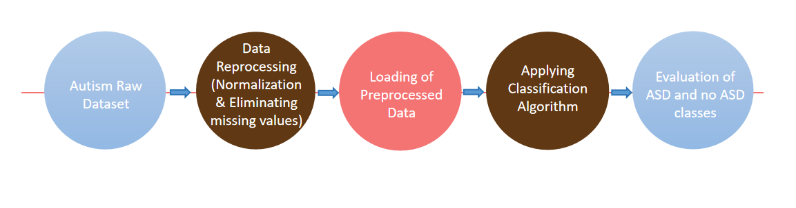
Fig.1. System Architecture

Dataset

Dataset Properties
- We are utilizing the UCI Machine Learning Repository provided by Fadi Fayez Thabtah.
- The child dataset consists of 292 records, with 141 classified as ASD and 151 as non-ASD.
- The adolescent dataset contains 104 records, with 63 classified as ASD and 41 as non-ASD.
- The adult dataset comprises 704 records, with 189 classified as ASD and 515 as non-ASD.
- Overall, there are 21 features, including 10 questions related to behavioral information (A1-A10), 10 demographic attributes, and one class label indicating ASD prediction.
- Here we used
i) A1_Score to A10_Score: Scores derived from the Autism Spectrum Quotient (AQ) 10-item screening tool.
ii) age: Patient's age ( in years).
iii) gender: Gender of Patient.
iv) ethnicity: Ethnic ground of Patient.
v) jaundice: Indicates if the patient had jaundice from birth.
vi) autism: Indicates if some immediate family member had ever diagnosed with ASD.
vii) country_of_res: Patient's home country.
viii) used_app_before: Indicates if patient had undergone a screening test ever.
ix) result: Score obtained from the AQ1-10 screening test.
x) age_desc:Patient's age description.
xi) Class/ASD: Classified result represented as 0 (No) or 1 (Yes). This column serves as the target variable, and values should be submitted as 0 or 1 only during submission.

Dataset Visualization

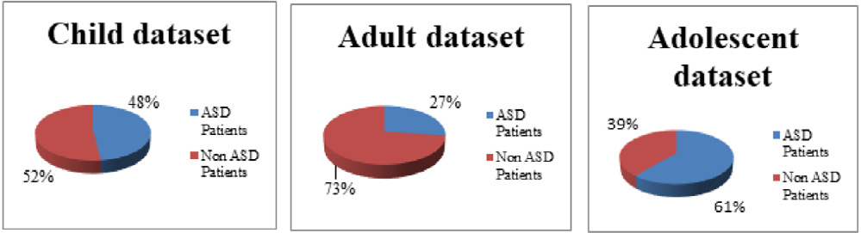
Fig.2. Dataset Visualization w.r.t.different age

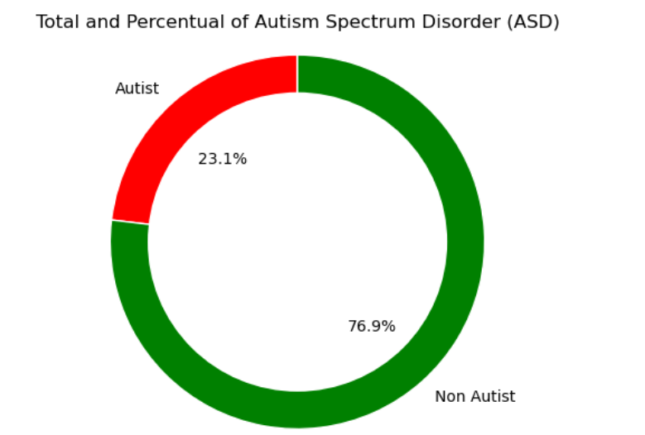
Fig.3. Total and Percentual of ASD

Comparison Studies

Metrices Equations
Accuracy = (TP + TN) / (TP + TN + FP + FN) (1)
Precision = TP / (TP + FP) (2)
Recall = TP / (TP + FN) (3)
F1-Score = 2 *(Recall * Precision) / (Recall + Precision) (4)
The above 4 equations are applied to compare the ML models.

Comparison in different ML algos
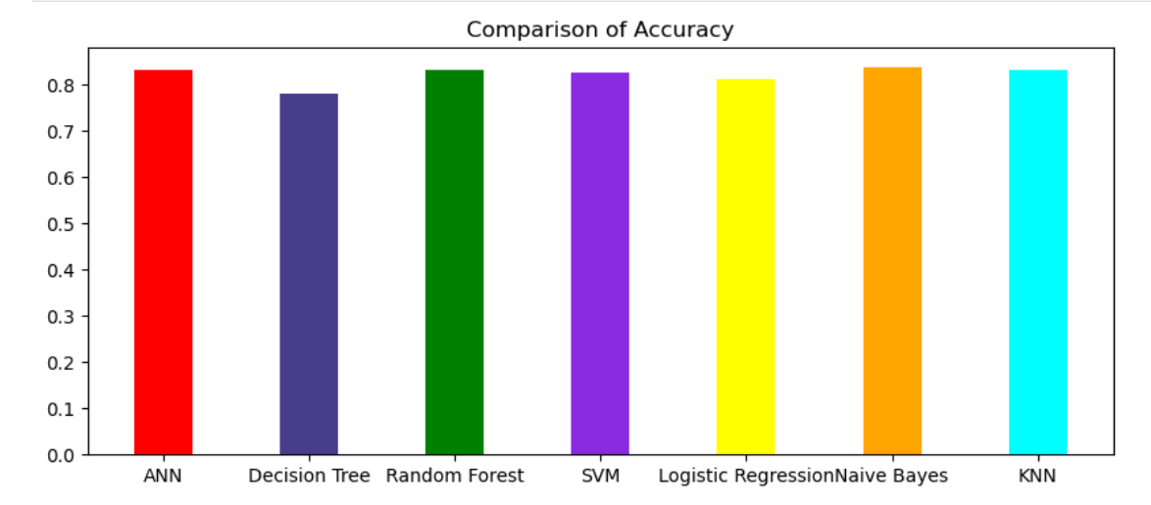
Fig.4. Comparison of Accuracy of different ML algorithms

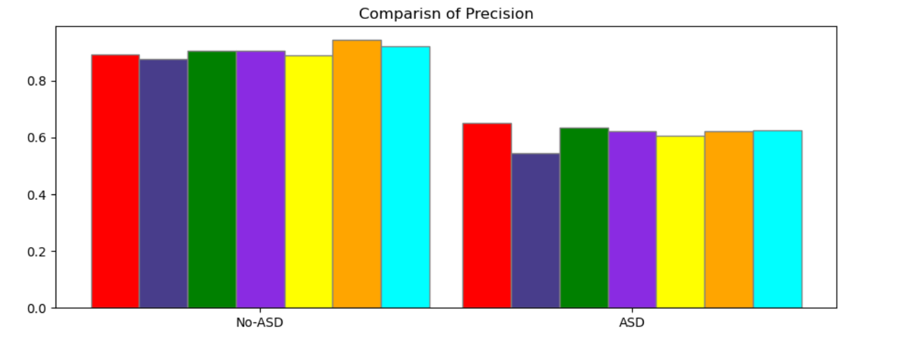
Fig.5. Comparison of Precision of different ML algorithms

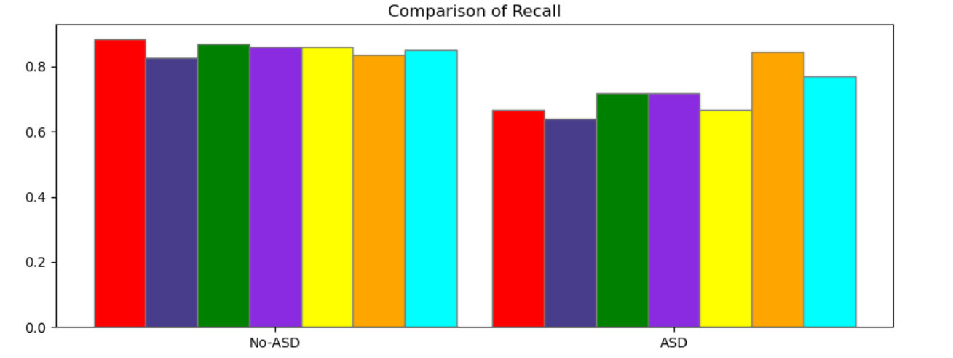
Fig.6. Comparison of Recall of different ML algorithms

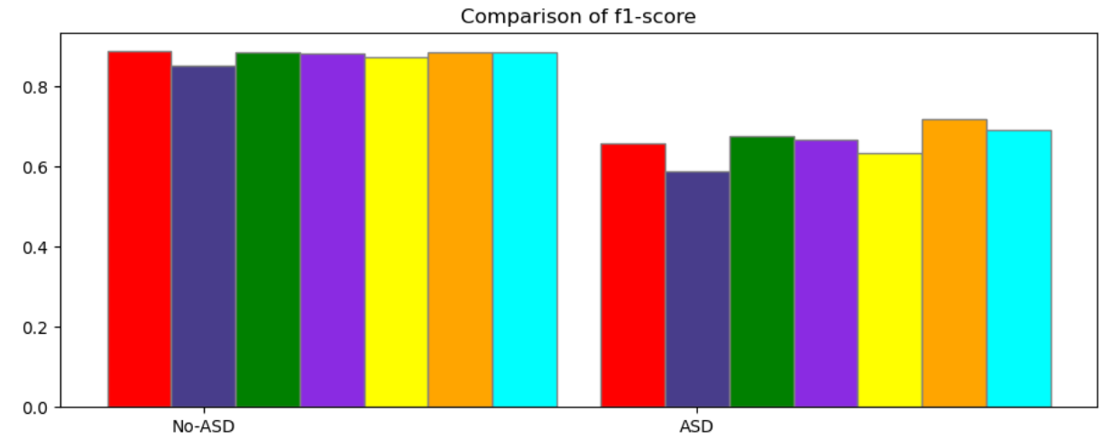
Fig.7. Comparison of f1-score of different ML algorithms

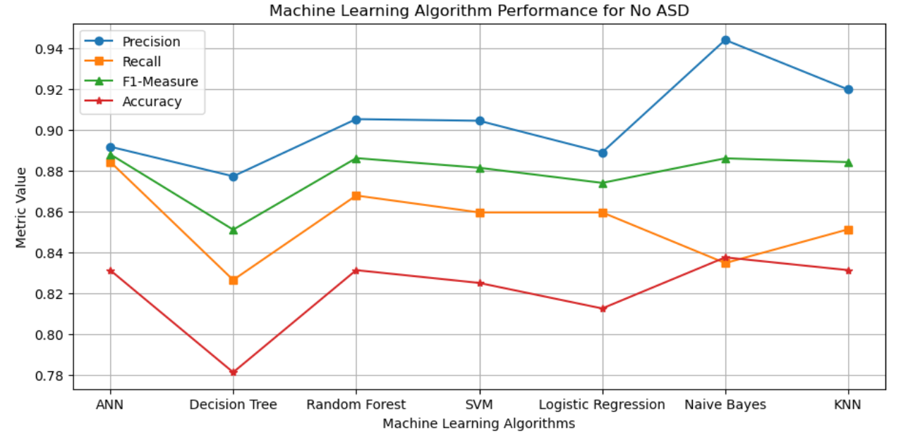

Fig.8. Comparison graph between metric values w.r.t. ML algorithms for No ASD
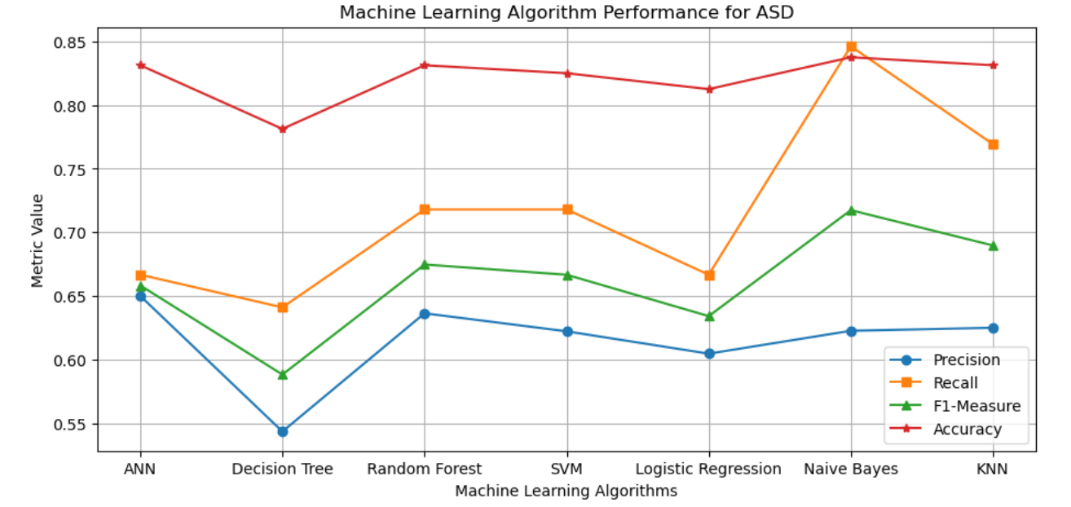

Fig.9. Comparison graph between metric values w.r.t. ML algorithms for ASD

Experimental Results
Classification Report:
NAME | accuracy | precision | recall | f1-score
ANN | 0.83125 | 0.65 | 0.67 | 0.66
Decision Tree | 0.78125 | 0.54 | 0.64 | 0.59
Random Forest | 0.83125 | 0.64 | 0.72 | 0.67
SVM | 0.825 | 0.62 | 0.72 | 0.67
Logistic Regression | 0.8125 | 0.60 | 0.67 | 0.63
Naive Bayes | 0.8375 | 0.62 | 0.85 | 0.72
KNN | 0.83125 | 0.62 | 0.77 | 0.69
Table 1

Limitations
As we move forward, the future holds promising developments in understanding, assessment, and management of the autism spectrum disorder (ASD). Here are some areas of future scope in the field:

Early Detection and Intervention
Improved neuroimaging, genetic testing, and behavioral assessments will enable earlier diagnosis and more effective early interventions.

Personalized Medicine
Tailoring treatments to individual genetic and biological profiles will enhance treatment effectiveness and reduce side effects.

Neuroscience and Brain-Computer Interfaces
Advances in neuroimaging and brain-computer interfaces (BCIs) could improve communication and interaction for those with ASD.

Artificial Intelligence and Data Analytics
AI and machine learning will enhance data analysis, early screening, and personalized treatment.

Digital Health Solutions
Mobile health technologies, wearables, and virtual/augmented reality will offer new methods for monitoring, intervention, and therapy.

Community Support and Advocacy
Increased focus on inclusive practices and advocacy will promote neurodiversity and social inclusion.
Through fostering interdisciplinary collaboration, harnessing technological advancements, and centering the requirements and perspectives of individuals dealing with autism disorder/disease and their family, we could strive towards a future where every person on the autism spectrum is empowered to flourish and achieve their full potential.

Conclusion
In conclusion, ASD presents as a complex neurodevelopmental disorder affecting individuals in various manners. Throughout this presentation, we've delved into its defining traits, diagnostic benchmarks, prevalence rates, and plausible origins. It's imperative to acknowledge the individuality of each person with autism, as they possess their distinct strengths and confront unique challenges.
While there is still much to learn about autism, increased awareness, acceptance, and support are essential for improving the lives of individuals on the spectrum. Early intervention and personalized therapies can significantly enhance outcomes and assist individuals with autism achieve their maximum potential.
As our comprehension of autism grows, let's aim for a society that celebrates neurodiversity, champions inclusivity, and guarantees equal opportunities for individuals of all abilities. Through collaborative efforts, we can cultivate a more compassionate and supportive global community that empowers and uplifts everyone, including individuals with autism.

References

- Chen, C. P., Keown, C. L., Jahedi, A., Nair, A., Pflieger, M. E., Bailey, B. A., & Müller, R. A. (2015). Diagnostic classification of intrinsic functional connectivity highlights somatosensory, default mode, and visual regions in autism. NeuroImage. Clinical, 8, 238–245.
- Duda, M., Ma, R., Haber, N., & Wall, D. P. (2016). Use of machine learning for behavioral distinction of autism and ADHD. Translational psychiatry, 6(2), e732.
- Sherkatghanad, Z., Akhondzadeh, M., Salari, S., Zomorodi-Moghadam, M., Abdar, M., Acharya, U. R., Khosrowabadi, R., & Salari, V. (2020). Automated Detection of Autism Spectrum Disorder Using a Convolutional Neural Network. Frontiers in neuroscience, 13, 1325.
- Kosmicki, J. A., Sochat, V., Duda, M., & Wall, D. P. (2015). Searching for a minimal set of behaviors for autism detection through feature selection-based machine learning. Translational psychiatry, 5(2), e514.
- Kothe, C. A., & Makeig, S. (2013). BCILAB: a platform for brain-computer interface development. Journal of neural engineering, 10(5), 056014.
- Nunes, A. S., Peatfield, N., Vakorin, V., & Doesburg, S. M. (2019). Idiosyncratic organization of cortical networks in autism spectrum disorder. NeuroImage, 190, 182–190.
- Oberman, L. M., Rotenberg, A., & Pascual-Leone, A. (2015). Use of transcranial magnetic stimulation in autism spectrum disorders. Journal of autism and developmental disorders, 45(2), 524–536.
- Thabtah, F. (2017). Autism spectrum disorder screening: Machine learning adaptation and DSM-5 fulfillment. Proceedings of the 1st International Conference on Medical and Health Informatics 2017, 1-6.
- Santosh P. J. (2000). Neuroimaging in child and adolescent psychiatric disorders. Archives of disease in childhood, 82(5), 412–419.
- Zablotsky, B., Black, L. I., Maenner, M. J., Schieve, L. A., & Blumberg, S. J. (2015). Estimated Prevalence of Autism and Other Developmental Disabilities Following Questionnaire Changes in the 2014 National Health Interview Survey. National health statistics reports, (87), 1–20.

